**NAME:** Ishimwe yasil

**Class:**  EAT A

**REG:** 21rp05233

**Industrial temperature automation monitoring**

**Objective of this project**

The main objective of this project is to build **Temperature Controlled Industrial Automation using Arduino**. The system build will be able to control your**industrial Appliances like Fan, Heater,Cooler** . Suppose you want your cooler or fan to be “**ON**” automatically, and then “**OFF**” when room temperature is back to normal. This project will help you to control your indusrial appliances automatically based on your room temperature.

**Table Of Contents**

1. **Components required**
2. [**Working of Temperature controlled Home Automation System**](https://iotprojectsideas.com/temperature-controlled-home-automation-using-arduino/#working-of-temperature-controlled-home-automation-system)
3. [**Schematic Diagram**](https://iotprojectsideas.com/temperature-controlled-home-automation-using-arduino/#schematic-diagram)
4. [**Program sketch/code**](https://iotprojectsideas.com/temperature-controlled-home-automation-using-arduino/#program-sketchcode)

**Components required**

**Tmp35**

**Arduino uno board**

**Bread board**

**Wire**

**20*4 lcd display**

**Fan**

**Potentiometer**

**Working of Temperature controlled industrialAutomation**

**This Temperature based industrial Automation System consists of components like the Arduino UNO board, 20×4 LCD display, fan, and Temperature Sensor. The whole system depends on the fan and TMP35, as the temperature increases the fan will be turned “ON” and if the temperature decreased below the preset value then fan will be**

**Be turned “OFF”. Here we have used a dc fan as an AC appliance for demonstration purposes. The entire fan triggering and setting temperature value is performed by the Arduino board. The** [programmed Arduino UNO](https://www.arduino.cc/en/Guide/ArduinoUno)**board provides details on the LCD screen when the temperature get changes**

[**circuit Diagram**](https://iotprojectsideas.com/temperature-controlled-home-automation-using-arduino/#schematic-diagram) **in fritzing**

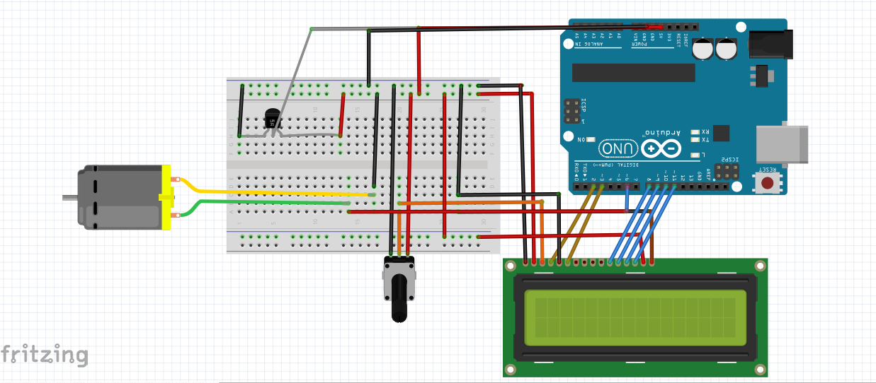

**Circuit in proteus**

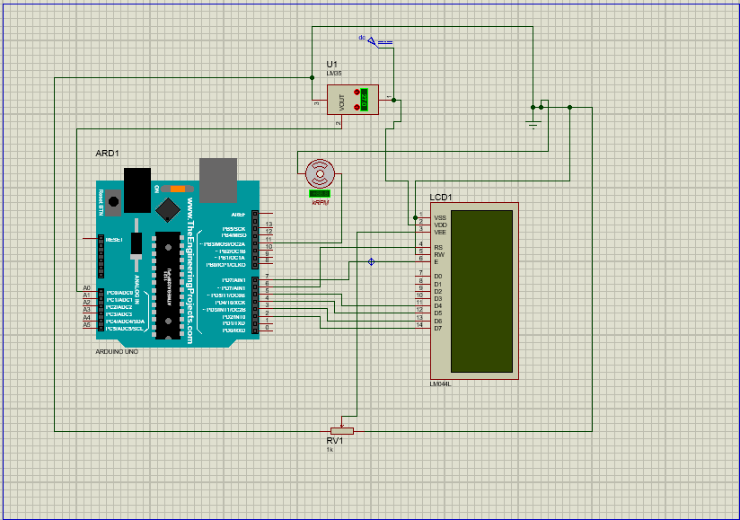

[**Program sketch/code**](https://iotprojectsideas.com/temperature-controlled-home-automation-using-arduino/#program-sketchcode)

#include <LiquidCrystal.h>

LiquidCrystal lcd(2,3,8,9,10,11);

int val;

int temPin=7;

void setup() {

Serial.begin(9600);

lcd.begin(20,4);

pinMode(6,OUTPUT);

}

void loop() {

val=analogRead(temPin);

float mv=(val/1023.0)*5000;

float cel=mv/63;

float farh=(cel*9)/5+32;

int t=22;

lcd.setCursor(0,0);

lcd.clear();//we start writing from the first row first column

if (cel > t) {

lcd.clear();

lcd.setCursor(0, 1);// move cursor to next line

lcd.print("Relay Status:");

lcd.print("ON"); // display the temperature

digitalWrite(6, HIGH);

}

else {

lcd.clear();

lcd.setCursor(0, 1);// move cursor to next line

lcd.print("Relay Status:");

lcd.print("OFF"); // display the temperature

digitalWrite(6, LOW);

}

lcd.clear();

lcd.setCursor(0, 0);

lcd.print("Temperature:");

lcd.print(cel); // display the temperature

lcd.print("C ");

lcd.setCursor(0,1);

lcd.print("Farh="); lcd.print(farh);

delay(5000);

lcd.clear();

}

**Conculsion**

As conclusion I have found that in some industries there is poor monitoring

Of temperature because of changing in temperature rapidly and during reducing temperature they do it by turning fan manual so this project

Will help in monitoring as it is automatic temperature monitoring

So it is very good choice for industries.